Purpose: Determine percent solids of slurry product

Equipment:
Weighing balance -- B440 Satorius
Gardner cup with lid

Procedure:
- After recording data from slurry sample bottle shake sample until all settling has re-suspended.
- Place empty Gardner cup with lid on balance and tare to zero.
- Remove cup from balance, remove lid and fill cup to just below the top edge.
- Replace lid on cup evenly.
- Excess slurry should seep out the hole in the lid, if no slurry comes out hole then remove lid and add more slurry.
- Wipe excess slurry off the cup and place back on the balance.
- For Gabbs, Superior and Aspers use the exact sequence of the following formula for solids results:

weight (g) ÷ 10 – 7.20 ÷ 95% x 10 = % solids
Example: 128.20g ÷ 10 – 7.20 ÷ 95% x 10 = 59.16

For Martin Marietta (MM) and Tetra material divide the weight by 10 and use the % solids chart.

% SOLIDS CHART

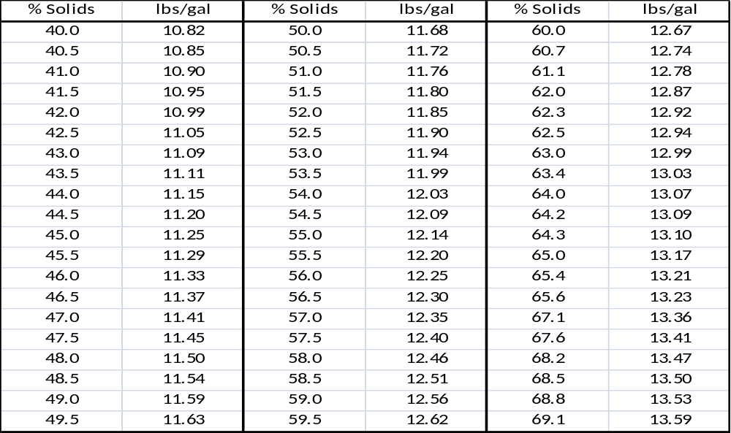

TRAINING DOCUMENTATION

 | EMPLOYEE | TITLE | SIGNATURE | DATE
1
2
3
4
5
6
7
8
9
10
11
12
13
14
15
16
17
18

Revision  Number | Revision  Date | Revision  Author | Revision Description
00 | 10/20/11 | LC | New Document

